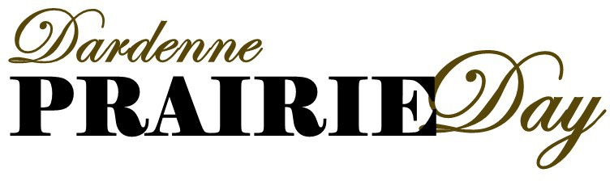
SATURDAY, October 1, 2022
12:00 P.M. - 5:00 P.M.

Vendor Information and Booth Registration
Please fill out both pages completely, sign and return to City of Dardenne Prairie
Attn: Prairie Day 2032 Hanley Road
Dardenne Prairie, MO 63368 or
FAX: (636)-625-0077 E-MAIL: jennifer.bohn@dardenneprairie.org

Business Name Contact Name Mailing Address Business Phone Cell Phone Email Address

BOOTH - (10 x 10 x 10) or Food Truck | REQUIREMENTS
Food Sales | - Health Department Permit required. (Please attach)  - Water or electrical hookups are not available.  - Vendor provided A.B.C. fire extinguisher required.
List items to be sold:
Merchant Vendor | - The City reserves the right to deny the sale of any items it deems unacceptable or inappropriate including but not limited to: carnival, flea market or garage sale items, firearms, knives, fireworks, or live animals.  - No tables or chairs provided.  - Water or electrical hookups are not available.
List items to be sold:
Vendor- No Sale Items | - No tables or chairs provided.  - Water or electrical hookups are not available.
List any giveaways, games, entertainment, or contests to be provided:
Please submit one application for each booth you plan to obtain.All applications MUST be received by August 31st.
After August 31st, applications will be accepted based on space availability.

INSTRUCTIONS FOR APPLICANTS
- All booth locations will be assigned by the City and will be located within City Hall Park unless otherwise noted. All vendors must utilize their assigned spaces. Trading/relocating assigned booth/truck spaces is not allowed.
- The City of Dardenne Prairie reserves the right to relocate any booth/truck during the event if it is deemed in the best interest of the event.
- Prior to the event, all vendors will be provided instructions as to proper set-up and tear-down procedures.
- Vendors will be responsible for their own tents or overhead canopy, tables, chairs, dollies, non-electrical illumination, and other operational equipment. Electric is not provided unless prior arrangements have been made with the City.
- Tents must be properly secured.
- Unless otherwise noted, all spaces will be ten (10) feet wide by ten (10) feet deep by ten (10) feet high.
- Applicants for booths will be notified upon approval at least four weeks prior to the event. Set-up and tear-down times will be announced at least two (2) weeks prior to the event. Vendor booths are non-transferable. Vendors that have signed an application are responsible for the booth.
- No self-contained units or generators will be allowed on event grounds. All equipment and supplies must fit in the assigned ten (10) feet wide by ten (10) feet deep by ten (10) feet tall area. Food trucks are exempted from this specification.
- The City has the right to deny or cancel any vendor that does not follow professional expectations.
- The City cannot guarantee exclusivity of merchandise for any vendor.
- All vendors will comply with the Missouri Department of Revenue tax collection rules. The City is not responsible for collection of taxes. For more information, please refer to this link: http://dor.mo.gov/faq/business/special.php.
- Food vendors may not dispense or sell any products in glass containers. All food waste must be disposed of properly. All vendor trash must be placed in an approved trash receptacle.
- All food vendors must follow the rules as set forth in “the guidelines for temporary events” as published by the St. Charles County Health Department. For more information, please refer to this link: www.scchealth.org or call the department at 636-949-7400 or toll free at 800-822-4012, ext. 7400.
- The City reserves the right to deny the sale of any items it deems unacceptable or inappropriate.
- Food trucks are not required to fit within the ten (10) feet wide by ten (10) feet deep by ten (10) feet high specification.

WAIVER AND RELEASE OF ALL CLAIMS AND ASSUMPTION OF RISK

(Business Name or Individual), for itself / myself, its/my employees, agents, participants and invitees, hereby expressly release(s), discharge(s) and forever hold(s) harmless, the City of Dardenne Prairie, Missouri, its officers, employees and agents from any claims, suits, demands, losses, costs and expenses (including attorneys’ fees) arising from or alleged to arise from the use of the property of the City or participation in the event described above, that may be sustained by (Business Name or Me), its / my employees, agents, participants or invitees while using of the property of the City or participating in the event described above. My signature on this form further gives permission to the City of Dardenne Prairie and its officers, employees, and agents to take photographs/video of me, my family and/or employees if applicable, at this event and to use these images for future promotions and/or in the organizations' publications and web media. I understand that I will not be allowed to participate in this event unless a signed registration form is on file with the City of Dardenne Prairie.

Printed Name Authorized Signature Date Signed

FOR OFFICE:
APPROVED
DENIED

